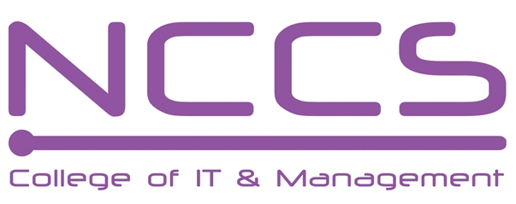
National College of Computer Studies
(NCCS-College of IT & Management)
Final Examination (2021)
BSc.CSIT/First Semester/ CSC 111 : Digital Logic

Candidates are required to answer the questions in their own words as far as practicable.

Full Marks: 60
Pass Marks: 30
Time: 3 Hours
Set B

Attempt any two questions. [2×10=20]
- What are combinational logic circuit design procedure? Design 4-bit binary to gray code conversion circuit.
- Define shift register. Explain SISO and PISO shift register with necessary diagram.
- What is asynchronous counter? Design a 4 bit synchronous even down counter using TFF.

Attempt any eight questions. [8×5=40]
- Convert (2B6AC.EF6) to decimal, octal and binary.
- Subtract the given number using 1’s complement.
a. 55₁₀-40₁₀ b. - 30₁₀-25₁₀
- Express F (A, B, C) =A'BC'+ (A+B') (B+C+AB') into Sum of Minterms and Product of Maxterms and simplify the result in POS using K map.
- Design a full adder logic circuit using ROM.
- What is DMUX? Design and explain block diagram only of 1*32 line DMUX using minimum number of 1*8 line and 1*4 line DMUX.
- Design the given Boolean function using PAL.
- X (A,B,C)= ∑ (0,1,2,3,5,7)
- Y(A,B,C)= ∑(1,2,3,4,6,7)
- What is race around condition in Flip-flop? Convert SR Flip-flop to JK flip-flop.
- Explain the Master-slave J-K flip-flop with logic diagram, truth table and timing diagram.
- Write short notes on:
a.) IC
b.) Decoder
c.) Johnson counter

********

Note: Please send your answer sheet to the following e-mail address.
To: csit10batch@nccs.edu.np
CC: er.bishnukc@gmail.com

